Practical No:-7
Create a Simple REST Service to demonstrate CRUD operations with “City” database. Implement the service with fields viz. City_Name, District_Name, Population. Deploy the service and Execute the operations.

Step1: Create a datbase and table
mysql> create database citydb_awaiz6013;
mysql>use citydb_sufyan6111;
mysql> create table City (
City_Name varchar(50),
District_Name varchar(50),
Population int
);
mysql> show tables;
mysql> desc City;
mysql> select * from City;
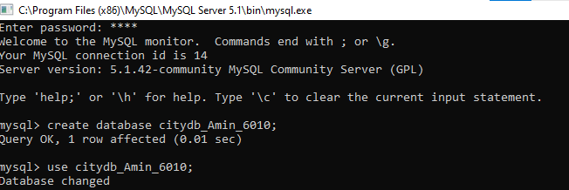
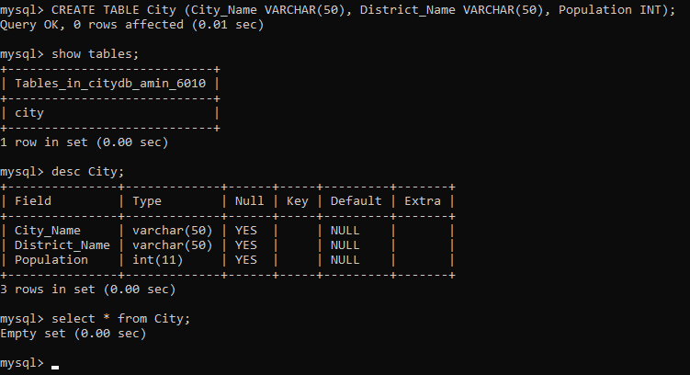

- Insert Data
package ServerPackage;
import javax.ws.rs.core.Context;
import javax.ws.rs.core.UriInfo;
import javax.ws.rs.Produces;
import javax.ws.rs.Consumes;
import javax.ws.rs.GET;
import javax.ws.rs.Path;
import javax.ws.rs.PUT;
import javax.ws.rs.core.MediaType;
import java.sql.*;
@Path("generic")
public class GenericResource {
@Context
private UriInfo context;
public GenericResource() {
}
@GET
@Produces(MediaType.APPLICATION_XML)
public String getXml() {
//TODO return proper representation object
throw new UnsupportedOperationException();
}
@PUT
@Consumes(MediaType.APPLICATION_XML)
public void putXml(String content) {
}
@PUT
@Consumes(MediaType.APPLICATION_XML)
@Path("/ExecuterQuery")
public String executeMyquery(String query)
{
try
{
Class.forName("com.mysql.jdbc.Driver");
String url = "jdbc:mysql://localhost/employeedb";
Connection con = DriverManager.getConnection(url,"root","maha");
Statement st = con.createStatement();
String q = query;
st.execute(q);
st.close();
con.close();
return "Query is Executed!!!";
}
catch (Exception e)
{
return e.getMessage();
}
}
}
Output:-
Insert Query
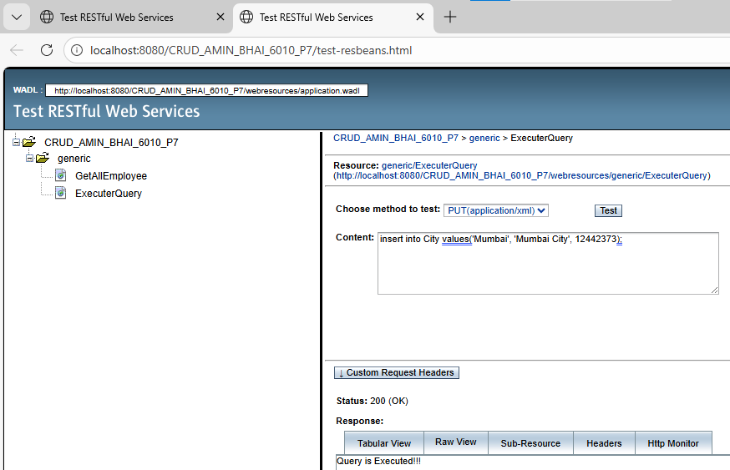

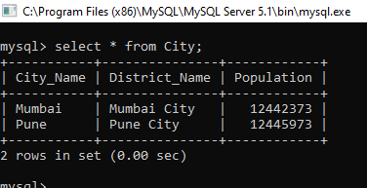

Update Query

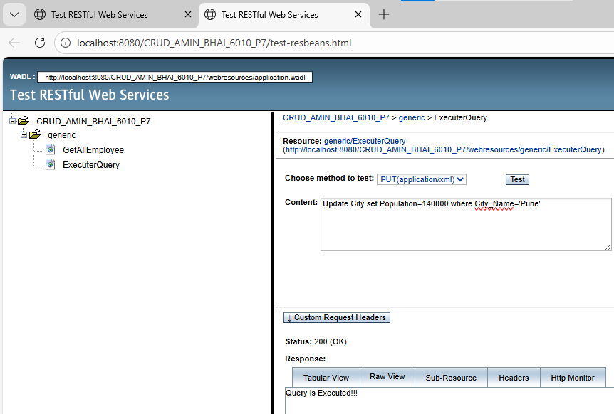

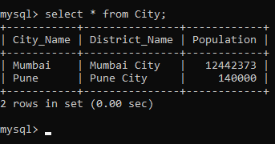

Delete Query

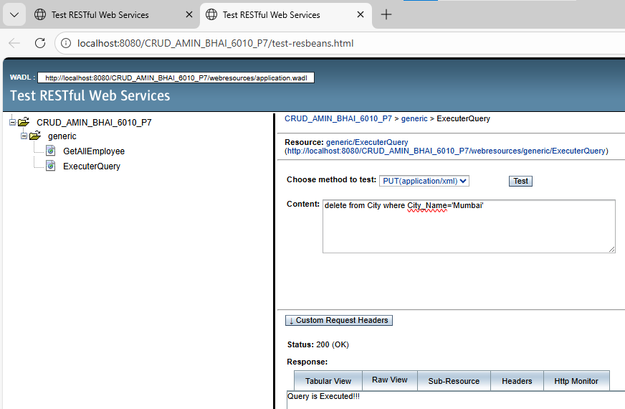

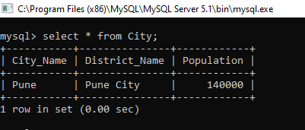

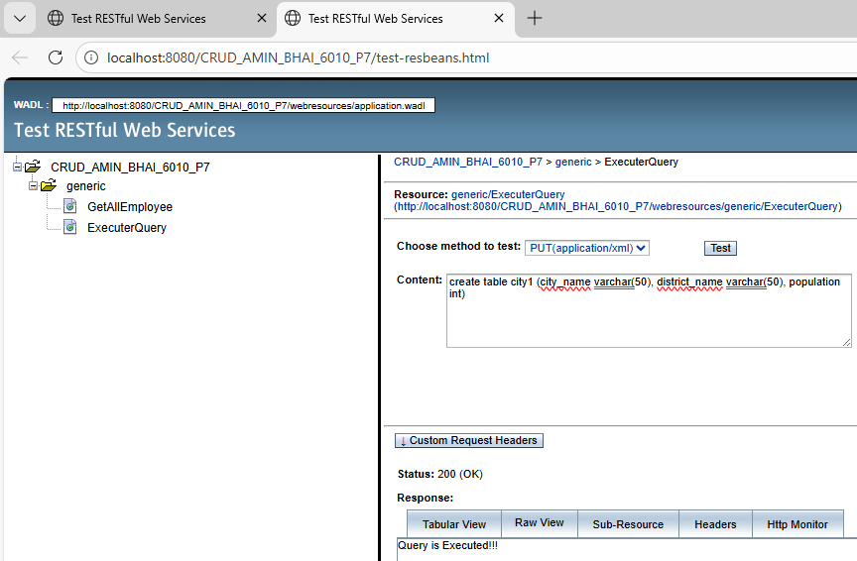

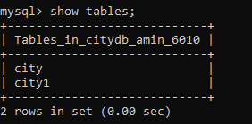

b) Retrieve all records
Code:
package ServerPackage;
import javax.ws.rs.core.Context;
import javax.ws.rs.core.UriInfo;
import javax.ws.rs.Produces;
import javax.ws.rs.Consumes;
import javax.ws.rs.GET;
import javax.ws.rs.Path;
import javax.ws.rs.PUT;
import javax.ws.rs.core.MediaType;
import java.sql.*;
@Path("generic")
public class GenericResource {
@Context
private UriInfo context;
public GenericResource() {
}

@GET
@Produces(MediaType.APPLICATION_XML)
public String getXml() {
//TODO return proper representation object
throw new UnsupportedOperationException();
}
@PUT
@Consumes(MediaType.APPLICATION_XML)
public void putXml(String content) {
}
@PUT
@Consumes(MediaType.APPLICATION_XML)
@Path("/ExecuterQuery")
public String executeMyquery(String query)
{
try
{
Class.forName("com.mysql.jdbc.Driver");
String url = "jdbc:mysql://localhost/employeedb";
Connection con = DriverManager.getConnection(url,"root","maha");
Statement st = con.createStatement();
String q = query;
st.execute(q);
st.close();
con.close();
return "Query is Executed!!!";
}
catch (Exception e)
{
return e.getMessage();
}
}
@PUT
@Consumes(MediaType.APPLICATION_XML)
@Path("/GetAllEmployee")
public String GetAllEmployee(String query)
{
try
{
Class.forName("com.mysql.jdbc.Driver");
String url = "jdbc:mysql://localhost/employeedb";
Connection con = DriverManager.getConnection(url,"root","maha");
Statement st = con.createStatement();
String q = query;
String data = "";
ResultSet rs = st.executeQuery(q);
while(rs.next())
{
data = data + rs.getString(1) +" ";
data = data + rs.getString(2) +" ";
data = data + rs.getString(3) +" ";
data = data + rs.getString(4) +" ";
}
st.close();
con.close();
return data;
}
catch (Exception e)
{
return e.getMessage();

}
}
}

Output
